4UU

Maxemilien DISSI

Post Graduate in Humanitarian Leadership & Management

Strategia Netherlands, Prinses Beatrixlaan 582595 BM, The Hague

November 15, 2019

Leadership styles in an organization - how effective they are.

LEADERSHIP IN HUMANITARIAN ORGANIZATIONS -CASE STUDY OF PLAN INTERNATIONAL

Table of Contents

Abstract 2

Acknowledgements 3

Introduction 4

Research Methodology 5

Results / Data Analysis. 6

Discussion. 14

The leadership styles 14

How effective the leadership styles are 15

Conclusion 18

References 19

# Abstract

The aim of this research work was been presenting leadership in Humanitarian Organizations, and in that case, we decided to work on how the leadership styles are effective in Humanitarian Organizations, Plan International in Central African Republic is one of a Humanitarian and Development Organizations which we selected and making a case study.

Three (3) main useful leadership styles are retained as a basis for this study, meaning (i) the authoritarian or autocratic style; (ii) the participative, or democratic or consultative style; and (iii) the delegative or free reign. Only the senior managers called of Country Leaders Team (CLT) members and Project managers based on their responsibility were identified as respondents for the survey regarding this case study.

We used the quota-sampling technique and then surveyed using a postal questionnaire. A postal questionnaire contained 30 questions (from 1 to 30), divided into three (3) main parts shuffled each other: (i) the authoritarian or autocratic style; (ii) the participative, or democratic or consultative style; and (iii) the delegative or free reign. The surveyed were invited by email to participate based on their position as leaders and experience working in the humanitarian sector. The survey took no more than 25 minutes of their time, and their email address were not linked to their responses. Google Form is platform used to gain access to the respondents to complete the survey in English only.

30 questionnaires posted online through Google forms were submitted, where ten (10) leaders (i.e. 56%) over 18 responded to this survey while, only one woman (6%). Eight (8) professional expertise areas are targeted for this survey. 20% of respondents (n=10) have minimum 3-4 years experiences in humanitarian sector while 10% have 20-30 years experiences. 30% of respondents (n=10) have minimum 3-5 staff who report to them directly while 40% of respondents have more than 10 staff who report to them directly. As summary of main results:

* **Autocratic or Authoritarian Style**
* 30% of the respondent negatives always keep process authority of final decision into their department or over their team
* 20% of the respondent negatives said, the employees are not allowed to make any decisions unless they first approve them.
* 20% of the respondent negatives like the power (power) that their position of leadership allows them to have on subordinates.
* **Participative, democratic, or Consultative Style**
* 30% of the respondent negatives said, each individual is responsible for defining their work.
* 40% of the respondents negatives said, employees have the right to determine their own organizational goals.
* **Delegative or free reign style**
* 40% of the respondent negatives said, the colleagues will direct themselves if they are impregnated with the objectives.

We end up by this conclusion, there is no such thing as an ideal leadership style. The situation in which leaders and their teams function will influence the approaches that leaders adopt. It all depends. The factors affecting the degree to which a style is appropriate will be the type of organization, the nature of the task, the characteristics of the group and, importantly, the personality of the leader.

# Acknowledgements

I would wish to acknowledge the contribution made by the following in preparing this research for their contribution as respondents and technical support:

**Mr. Safo VISHA;** **Mr. Richard FORREST; Mr. Richard KAMBOU; Miss. Caroline BUSINE; Mr. Jacques KACHUKA; Mr. Ousmanou HAMADOU; Mr. Leonard NDI; Mr. Gilbert NGAH; and Mr. Kader DEMBELE.**

Post Graduate Diploma in Humanitarian Leadership, November 2019; Strategia Netherlands, Prinses Beatrixlaan 582595 BM, The Hague, Netherlands

# Introduction

This research work conducted by Maxemilien Dissi from September - November 2019 as part of assignment of Postgraduate in Humanitarian Leadership and Management, followed at Strategia Netherlands, Prinses Beatrixlaan 582595 BM, The Hague, Netherlands. The research included the result of leadership style survey conducted with close of management team of Plan International in Central Africa Republic. The relevant statistics and measure as from July 1st to November 20th, 2019. This research is the case study of leadership style in an organization, which captured how effective the leadership styles are in practice in an one of International Humanitarian and Development organizations. Moreover, for that case, we choose the Plan International Central African Republic’s case. Responding to this question – why would we like choose this topic? Because in the lifetime, most leaders will face during their tenure as leaders, whether working for a corporation or for themselves. Five (5) points summarize these challenges: how creating and maintaining a diversified Team - all leaders work with teams. How inspiring others to share the leader/organizational vision - a mission and vision are essential to any successful business. How facilitating open and clear communication among coworkers - clear and concise communication is essential for success. How empowering supervisees to take action - the days of micromanagement are over. In addition, how providing inspiration to others - a leader must provide inspiration to others.

This work research benefited the effective participation of Country Leader Team (CLT) member of Plan International Central African Republic as respondents to leadership style survey conducted.

There are normally three styles of leadership: (a) the authoritarian or autocratic style; (b) the participative, or democratic or consultative style; and (c) the delegative or free reign. Although good leaders use all three styles, with one of them normally dominating, bad leaders tend to stick with one style.

The succinct statements of the aims objects that this research is going to address are: Why do people work? What is a leader? What are the types of leaders? What do leaders do? How do leaders do it? What makes a good leader?

A clear and unambiguous point of this research is differentiating between Management and Leadership. Therefore, the Leadership and management are two notions used to describe two related concepts. Managers do things right, leaders do the right thing. However, this distinction is too facile and too simple. These differences are bit discussed, explaining why both terms are thought to be similar.

Leading involves influencing others toward the attainment of organizational objectives. Effective leading requires the manager to motivate subordinates, communicate effectively, and effectively use power. If managers are effective leaders, their subordinates will be enthusiastic about exerting effort toward the attainment of organizational objectives. To become effective at leading, managers must first understand their subordinates' personalities, values, attitudes, and emotions. Therefore, the behavioural sciences have made many contributions to the understanding of this function of management. Personality research and studies of job attitudes provide important information as to how managers can most effectively lead subordinates.

# Research Methodology

This research objective previously indicated is part of assignment Postgraduate in Humanitarian Leadership Management; followed at Strategia Netherlands, Prinses Beatrixlaan 582595 BM, The Hague, Netherlands. As leadership in Humanitarian Organization is so huge, we are limited to on Leadership Styles in Organizations specially case study of Plan International in Central African Republic – One of International Humanitarian and Development Organizations.

In fact, we started ou thinking about what is difference between Management and Leadership and end up by Leadership has two implied meanings. It can be defined in terms of position, as in being in a leadership position. A more fruitful way to think about leadership concerns the distinction between occupying a leadership position and being effective in that position. Leadership ought to be evaluated in terms of the performance of the group over time. It relates directly to the ability to build and maintain a group that performs well compared to its competition.

Leadership is just one of the many assets a successful manager must possess. The principal aim of a manager is to maximize the output of the organization through administrative implementation. To achieve this, managers must undertake the following five (5) functions: organization; planning; staffing; controlling and directing.

Leadership is an important component of the directing function. A manager must manage as well as lead. Managers need formal authority to be effective. Leaders must often let vision, strategies, goals, and values guide the group action and behaviour rather than attempting to control others. Thus, Studies of leadership and leadership style provide information regarding questions such as, "What makes a manager a good leader?" and "In what situations are certain leadership styles most appropriate and effective?"

Given the problem to be investigated – the leadership Styles in an Organization, how effective they are. The Country Leader Team (CLT) members of Plan International in Central Africa Republic are the suitable respondents were sampled using quota sampling technique and then surveyed using a postal questionnaire.

A postal questionnaire contained 30 questions (from 1 to 30), divided into three (3) main parts shuffled each other: (i) the authoritarian or autocratic style; (ii) the participative, or democratic or consultative style; and (iii) the delegative or free reign. The surveyed were invited by email to participate based on their position as leaders and experience working in the humanitarian sector. The survey took no more than 25 minutes of their time, and their email address were not linked to their responses. Google Form is platform used to gain access to the respondents to complete the survey in English only.

Ten (10) leaders (i.e. 56%) over 18 responded to this survey while, only one woman (6%) are participated to this survey, the data are representative in term of trend of leaders’ statements regarding leadership styles. Noticed that, Plan International in Central Africa Republic contains in this survey period 287 staff (185 males and 102 females). It is leading by 12 Senior Managers (1 country Director, 1 Head of Program Operations, 1 Head of Program Strategy, 1 Finance Manager, 1 Human Resources Manager, 1 Business Development Manager, 1 Operation Manager,1 Portfolio Manager, 4 Head of Sub Offices/Field Managers); and 16 project managers. The next chapter comes up with more detail of results and any analysis related the data collected.

# Results / Data Analysis.

These results present from Leadership styles survey as part of work research of assignment of postgraduate in humanitarian leadership management, which I followed at Strategia Netherlands, Prinses Beatrixlaan 582595 BM, The Hague, Netherlands from December 2019 to November 2019 only in English.

Ten (10) leaders (i.e. 56%) over 18 responded to this survey while, only one woman (6%).

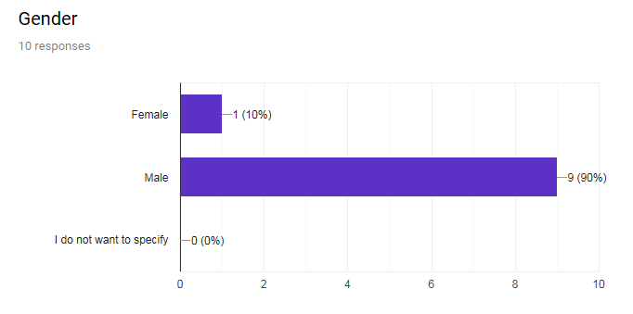

Figure 1: Gender graphic of respondents

*Eight (8) professional expertise areas are targeted for this survey*

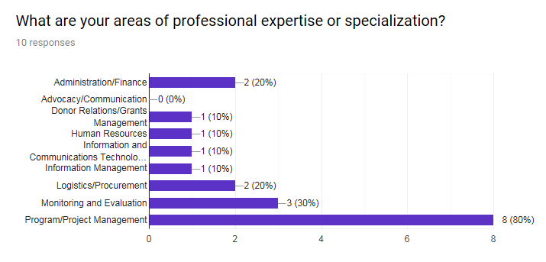

Figure 2: Graphic of respondents by professional expertise area

*20% of respondents (n=10) have minimum 3-4 years experiences in humanitarian sector while 10% have 20-30 years experiences*

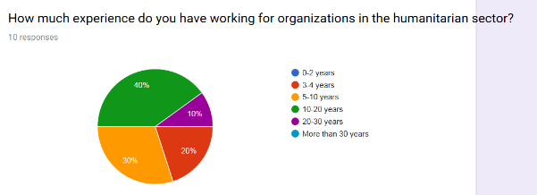

Figure 3: Graphic of respondents by experience year in humanitarian sector

*30% of respondents (n=10) have minimum 3-5 staff who report to them directly while 40% of the respondents have more than 10 staff who report to them directly.*

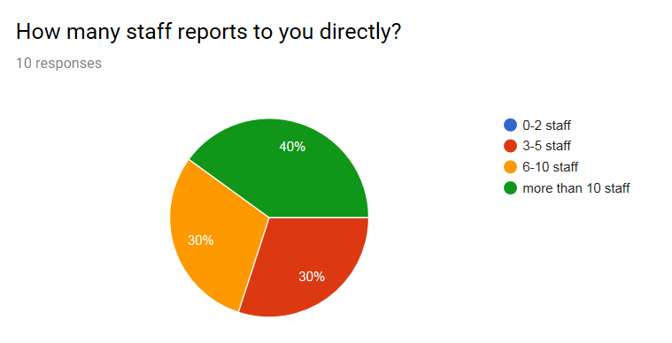

Figure 4: Graphic of respondents by number of staff who reports to them directly

The report uses five (5) key measures:

* **Strongly Positive** percentage (%) figures: are calculated as % Strongly Agree for positively phrased questions and % Strongly Disagree for negatively phrased questions
* **Positive** percentage (%) figures: are calculated as % Agree for positively phrased questions and % Disagree for negatively phrased questions
* **Neutral** percentage (%) figures: are calculated as % Neither Agree nor Disagree
* **Negative** percentage (%) figures: are calculated as % Disagree for positively phrased questions and % Agree for negatively phrased questions
* **Strongly Negative** percentage (%) figures: are calculated as % Strongly Disagree for positively phrased questions and % Strongly Agree for negatively phrased questions
* Results are presented as whole numbers for ease of reading. Therefore, in some instances, results may not total 100%.
* The report also uses the measure Overall Positive %'. This is calculated as % Strongly Positive + % Positive.
* The report also uses the measure 'Overall Negative %'. This is calculated as % Strongly Negative + % Negative.
* The “**# of respondent**” line shows the number of respondents –leaders who participated to the survey. This number is only displayed at question level and not at topic average level.

**Traffic Light Scoring**

Scores for the survey results are given a traffic light rating, based on the following:

|  |  |
| --- | --- |
| Green Traffic Light | 70% or more of respondents Positive and less than 20% of respondents Negative |
| Blue Traffic Light | Between 50 - 70% of respondents Positive and less than 20% of respondents Negative |
| Amber Traffic Light | Less than 50% of respondents Positive or 20% - 30% of respondents Negative |
| Red traffic light | 30% or more of respondents Negative |

All questions

| **Questions** | **Whole leader** |
| --- | --- |
| # of respondent | 10 |
| 1- I always keep process authority of final decision into my department or over my team | 70% |
| 2- I always try to include one or more colleagues determining what to do and how to do it. However, I maintain (interviews) the final decision-making authority. | 100% |
| 3- My colleagues and I always vote every time a major decision is made. | 70% |
| 4- I do not consider the suggestions made by my colleagues, because I do not have time for them. | 90% |
| 5-I ask my staff for ideas and I include them in future plans and projects. | 100% |
| 6- For a main decision to be made in my department, it must have the approval of each individual or the majority. | 70% |
| 7- I tell my colleagues what needs to be done and how to do it. | 90% |
| 8- When things go wrong and I have to create a strategy to run a project or run it according to the timing of the process; I call a meeting to get advice from my staff. | 100% |
| 9- To output the information, I send it via e-mail, notes, or Skype call; I call a meeting very rarely. I expect my employees to react on the information. | 50% |
| 10- When someone makes a mistake, I tell him never to repeat and I write a note. | 70% |
| 11- I want to create an environment where employees take ownership of the project. I allow them to participate in the decision-making process. | 90% |
| 12- I allow my team to determine what they need to do the job and how they will do it. | 90% |
| 13- Employees are not allowed to make any decisions unless they are first approved by me | 60% |
| 14- I ask colleagues for their views on their jobs and then I use their views when necessary. | 80% |
| 15- My associates know everything about their job descriptions and therefore I allow them to make decisions to do their job. | 100% |
| 16- When something goes wrong, I tell my associates that something is wrong with our procedures and I set up new ones. | 90% |
| 17- I allow my colleagues to use my advice to achieve their priorities. | 100% |
| 18- I delegate tasks to implement a new procedure. | 90% |
| 19- I closely monitor my colleagues to ensure they are performing their tasks correctly. | 100% |
| 20- When there are differences of expectations about roles and expectations, I work with them to resolve the differences. | 100% |
| 21 - Each individual is responsible for defining their work. | 60% |
| 22- I like the power (power) that my position of leadership allows me to have on subordinates. | 80% |
| 23- I like to use my power of directing to help subordinates grow up. | 100% |
| 24- I like to share my power of directing with my subordinates. | 100% |
| 25- Colleagues must be led or threatened with punishment to achieve organizational goals. | 100% |
| 26- The colleagues will direct themselves if they are impregnated with the objectives. | 50% |
| 27- Employees have the right to determine their own organizational goals. | 40% |
| 28- Employees are primarily seeking safety. | 80% |
| 29- Colleagues know how to use creativity and ingenuity to solve organizational problems. | 100% |
| 30- my colleagues can work as well as me. | 100% |

Figure 5: Results of survey based on all questions

Autocratic or Authoritarian Style

Autocratic or authoritarian style figures are presented on the following bases:

* questions : 1,4,7,10,13,16,19,22,25, and 28.
* The Autocratic leaders define the roles and tasks of their followers, and supervise them closely. Decisions are made and announced by the leader, and communication is largely one-way.

|  |  |  |  |  |  |  |  |
| --- | --- | --- | --- | --- | --- | --- | --- |
| **Key** | **Strongly Positive** | **Positive** | **Neutral** | **Negative** | **Strongly Negative** |  | |
|  |  |  |  |  |  |  |  |
| **Autocratic or Authoritarian Style** | | | | | | **Overall Positve** | **Traffic light** |
| 1- I always keep process authority of final decision into my department or over my team | 20% | 50% | 0% | 30% | 0% | **70%** |  |
| 4- I do not consider the suggestions made by my colleagues, because I do not have time for them. | 80% | 10% | 0% | 0% | 10% | **90%** |  |
| 7- I tell my colleagues what needs to be done and how to do it. | 40% | 50% | 10% | 0% | 0% | **90%** |  |
| 10- When someone makes a mistake, I tell him never to repeat and I write a note. | 10% | 60% | 20% | 10% | 0% | **70%** |  |
| 13- Employees are not allowed to make any decisions unless they are first approved by me | 30% | 30% | 20% | 10% | 10% | **60%** |  |
| 16- When something goes wrong, I tell my associates that something is wrong with our procedures and I set up new ones. | 20% | 70% | 0% | 10% | 0% | **90%** |  |
| 19- I closely monitor my colleagues to ensure they are performing their tasks correctly. | 30% | 70% | 0% | 0% | 0% | **100%** |  |
| 22- I like the power (power) that my position of leadership allows me to have on subordinates. | 50% | 30% | 0% | 20% | 0% | **80%** |  |
| 25- Colleagues must be led or threatened with punishment to achieve organizational goals. | 60% | 40% | 0% | 0% | 0% | **100%** |  |
| 28- Employees are primarily seeking safety. | 30% | 50% | 10% | 10% | 0% | **80%** |  |

Figure 6: Autocratic or authoritarian style figures

*30% of the respondent negatives always keep process authority of final decision into their department or over their team*

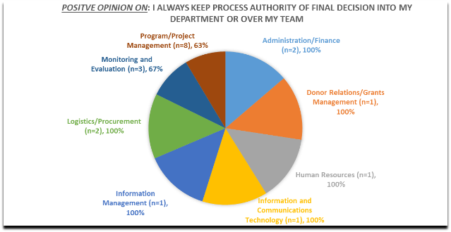

Figure 7: 1- I always keep process authority of final decision into my department or over my team

*20% of the respondent negatives said, the employees are not allowed to make any decisions unless they first approve them.*

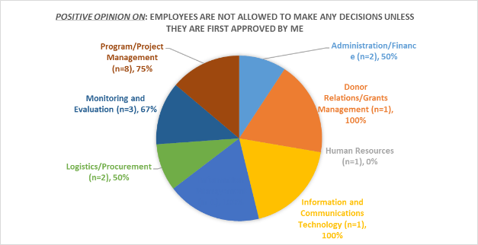

Figure 8: 13- Employees are not allowed to make any decisions unless they are first approved by me

*20% of the respondent negatives like the power (power) that their position of leadership allows them to have on subordinates.*

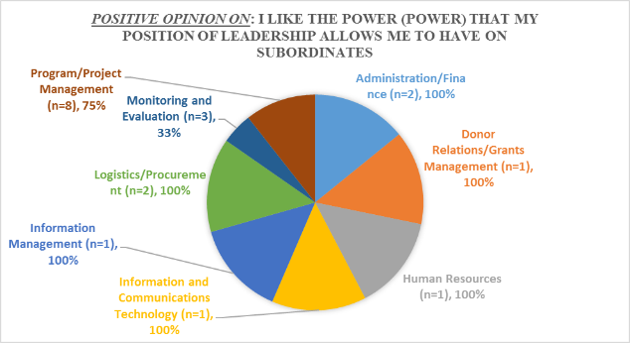

Figure 9: 22- I like the power (power) that my position of leadership allows me to have on subordinates.

Participative, democratic, or Consultative Style

Participative democratic or consultative Style figures are presented on the following bases:

* questions : 3,6,9,12,15,18,21,24,27, and 30.
* Participative leaders still define roles and tasks, but seek ideas and suggestions from the followers. Decisions remain the leader’s prerogative, but communication is much more two-way.

|  |  |  |  |  |  |  |  |
| --- | --- | --- | --- | --- | --- | --- | --- |
| **Key** | **Strongly Positive** | **Positive** | **Neutral** | **Negative** | **Strongly Negative** |  | |
|  |  |  |  |  |  |  |  |
| **Participative or Democratic or Consultative Style** | | | | | | **Overall positive** | **Traffic light** |
| 3- My colleagues and I always vote every time a major decision is made. | 10% | 60% | 30% | 0% | 0% | 70% |  |
| 6- For a main decision to be made in my department, it must have the approval of each individual or the majority. | 30% | 40% | 10% | 10% | 10% | 70% |  |
| 9- To output the information, I send it via e-mail, notes, or Skype call; I call a meeting very rarely. I expect my employees to react on the information. | 10% | 40% | 20% | 20% | 10% | 50% |  |
| 12- I allow my team to determine what they need to do the job and how they will do it. | 40% | 50% | 10% | 0% | 0% | 90% |  |
| 15- My associates know everything about their job descriptions and therefore I allow them to make decisions to do their job. | 30% | 70% | 0% | 0% | 0% | 100% |  |
| 18- I delegate tasks to implement a new procedure. | 20% | 70% | 0% | 10% | 0% | 90% |  |
| 21 - Each individual is responsible for defining their work. | 20% | 40% | 10% | 30% | 0% | 60% |  |
| 24- I like to share my power of directing with my subordinates. | 30% | 70% | 0% | 0% | 0% | 100% |  |
| 27- Employees have the right to determine their own organizational goals. | 0% | 40% | 20% | 30% | 10% | 40% |  |
| 30- my colleagues can work as well as me. | 60% | 40% | 0% | 0% | 0% | 100% |  |

Figure 10: Participative democratic or consultative Style figures

*30% of the respondent negatives said, each individual is responsible for defining their work.*

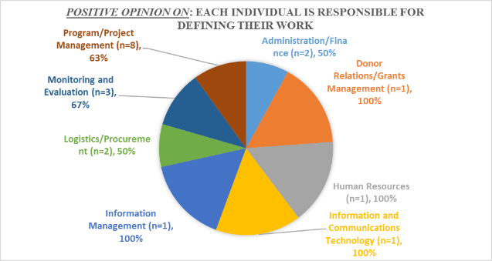

Figure 11: 21 - Each individual is responsible for defining their work.

*40% of the respondents negatives said, employees have the right to determine their own organizational goals.*

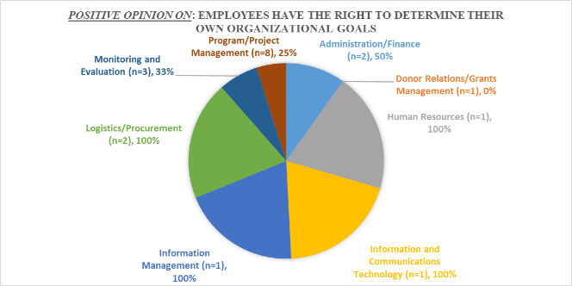

Figure 12: 27- Employees have the right to determine their own organizational goals.

**Delegative or free reign style**

Delegative or free reign style figures are presented on the following bases:

* questions : 2,5,8,11,14,17,20,23,26, and 29.
* The Delegative leaders are still involved in decisions and problem-solving, but control is with the follower. The follower decides when and how the leader will be involved.

|  |  |  |  |  |  |  |  |
| --- | --- | --- | --- | --- | --- | --- | --- |
| **Key** | **Strongly Positive** | **Positive** | **Neutral** | **Negative** | **Strongly Negative** |  | |
|  |  |  |  |  |  |  |  |
| **Delegative or free reign style** | | | | | | **Overall Positive** | **Traffic light** |
| 2- I always try to include one or more colleagues determining what to do and how to do it. However, I maintain (interviews) the final decision-making authority. | 40% | 60% | 0% | 0% | 0% | 100% |  |
| 5-I ask my staff for ideas and I include them in future plans and projects. | 70% | 30% | 0% | 0% | 0% | 100% |  |
| 8- When things go wrong and I have to create a strategy to run a project or run it according to the timing of the process; I call a meeting to get advice from my staff. | 20% | 80% | 0% | 0% | 0% | 100% |  |
| 11- I want to create an environment where employees take ownership of the project. I allow them to participate in the decision-making process. | 60% | 30% | 0% | 0% | 10% | 90% |  |
| 14- I ask colleagues for their views on their jobs and then I use their views when necessary. | 30% | 50% | 10% | 10% | 0% | 80% |  |
| 17- I allow my colleagues to use my advice to achieve their priorities. | 20% | 80% | 0% | 0% | 0% | 100% |  |
| 20- When there are differences of expectations about roles and expectations, I work with them to resolve the differences. | 50% | 50% | 0% | 0% | 0% | 100% |  |
| 23- I like to use my power of directing to help subordinates grow up. | 50% | 50% | 0% | 0% | 0% | 100% |  |
| 26- The colleagues will direct themselves if they are impregnated with the objectives. | 10% | 40% | 10% | 10% | 30% | 50% |  |
| 29- Colleagues know how to use creativity and ingenuity to solve organizational problems. | 10% | 90% | 0% | 0% | 0% | 100% |  |

Figure 13: Delegative or free reign style figures

*40% of the respondent negatives said, the colleagues will direct themselves if they are impregnated with the objectives.*

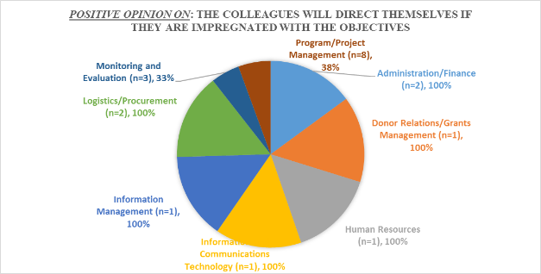

Figure 14: 26- The colleagues will direct themselves if they are impregnated with the objectives.

# Discussion.

This research is focused essentially on leadership styles in an organization, particularly how effective they are. Leading involves influencing others toward the attainment of organizational objectives. The leadership is the process of getting people to do their best to achieve a desired result. It involves developing and communicating a vision for the future, motivating people and gaining their engagement. Effective leading requires the manager to motivate subordinates, communicate effectively, and effectively use power. The leader should recognize the successes within a team. Leaders are observant and sensitive people. They know their team and develop mutual confidence within it.

## The leadership styles

Leadership is influencing people meaning, providing purpose, direction, and motivation. While operating to accomplish the mission and improving the organization. Leadership styles are the manner and approach of providing direction, implementing plans, and motivating people. There are normally three (3) main styles of leadership (authoritarian or autocratic; participative or democratic or consultative; and delegative or free reign). Although good leaders use all three styles, with one of them normally dominating, bad leaders tend to stick with one style.

Authoritarian (autocratic)

This style is used when the leader tells her employees what she wants done and how she wants it done, without getting the advice of her followers. Some of the appropriate conditions to use it are when you have all the information to solve the problem, you are short on time, and your employees are well motivated. The authoritarian style should normally only be used on rare occasions. If you have the time and want to gain more commitment and motivation from your employees, then you should use the participative style.

Participative, consultative democratic

This type of style involves the leader including one or more employees in on the decision making process (determining what to do and how to do it). However, the leader maintains the final decision making authority. This is normally used when you have part of the information, and your employees have other parts. Using this style is of mutual benefit if--it allows them to become part of the team and allows you to make better decisions.

Delegative (free reign)

In this style, the leader allows the employees to make the decision. However, the leader is still responsible for the decisions that are made. This is used when employees are able to analyze the situation and determine what needs to be done and how to do it. You cannot do everything! You must set priorities and delegate certain tasks. This is not a style to use so that you can blame others when things go wrong, rather this is a style to be used when you have the full trust and confidence in the people below you. Do not be afraid to use it, however, use it wisely!

Leaders adopt other different leadership styles, sometimes called management styles. To varying degrees, leaders can be achievement orientated, task orientated or people orientated. They can be:

* **Charismatic/non-charismatic**: ***Charismatic*** leaders originally described by Weber 1947, rely on their personality, their inspirational qualities and their ‘aura’. ***Non-charismatic*** leaders rely mainly on their knowhow (authority goes to the person who knows), their quiet confidence and their cool, analytical approach to dealing with problems.
* **Enabler/controller:** ***Enablers*** inspire people with their vision of the future and empower them to accomplish team goals. ***Controllers*** command people to obtain their compliance.
* **Transactional/transformational:** ***Transactional*** leaders originally described by Burns 1978, trade money, jobs and security for compliance. ***Transformational*** leaders defined by Bass 1985, motivate people to strive for higher-level goals.

Other classifications of leadership styles have been produced by House (1971) – the path-goal model – and by Hay McBer, as reported by Goleman (2000).

**Path-goal leadership theory identifies the following styles**:

* **Achievement-oriented** – the leader sets challenging goals for followers, expects them to perform at their highest level, and shows confidence in their ability to meet this expectation. This style is appropriate when the follower suffers from a lack of job challenge.
* **Directive** – the leader lets followers know what is expected of them and tells them how to perform their tasks. This style is appropriate when the follower has an ambiguous job.
* **Participative** – the leader consults with followers and asks for their suggestions before making a decision. This style is appropriate when the follower is using improper procedures or is making poor decisions.
* **Supportive** – the leader is friendly and approachable and shows concern for the psychological well-being of followers. This style is appropriate when the followers lack confidence.

## How effective the leadership styles are

Effective leaders are versatile in being able to move between the styles according to the situation, so there is no one right style. However, people tend to have a preferred style and should understand what that is.

Four (4) main major factors in leadership are import to be recalled here

1. **Follower:** Different people require different styles of leadership. A person who lacks motivation requires a different approach than one with a high degree of motivation. The fundamental starting point is having a good understanding of human nature, such as needs, emotions, and motivation.
2. **Leader**: must have an honest understanding of who he is, what he knows, and what he can do. Also, note that it is the followers, not the leader who determines if a leader is successful. If they do not trust or lack confidence in their leader, then they will be uninspired. To be successful he has to convince his followers, not himself or his superiors, that he is worthy of being followed.
3. **Communication**: Leader leads through two-way communication. Much of it is nonverbal. For instance, when he "set the example," that communicates to his people that he would not ask them to perform anything that he would not be willing to do. What and how he either communicates builds or harms the relationship between him and his employees.
4. **Situation**: All are different. What he does in one situation will not always work in another. He must use his judgment to decide the best course of action and the leadership style needed for each situation.

As originally described by Hersey and Blanchard (1969), a situational leader is one who can adopt different leadership styles depending on the situation. The behaviour of leaders towards their followers can take the following forms:

* **Directing leaders** define the roles and tasks of their followers, and supervise them closely. Decisions are made and announced by the leader, so communication is largely one-way.
* **Delegating leaders** are still involved in decisions and problem-solving, but control is with the follower. The follower decides when and how the leader will be involved.
* **Coaching leaders** still define roles and tasks, but seek ideas and suggestions from the followers. Decisions remain the leader’s prerogative, but communication is much more two-way.
* **Supporting leaders** pass day-to-day decisions, such as task allocation and processes, to followers. Leaders facilitate and take part in decisions, but control is with the follower.

Five (5) challenges most leaders will face during their tenure as leaders, whether working for a corporation or for themselves:

**Challenge 1 – Creating and maintaining a diversified team**

One of the greatest challenges of leadership in modern society is finding ways to create a unified front among team members. A leader can overcome the challenges associated with creating and preserving a diversified team by encouraging horizontal communication and knowledge sharing. The best way to create and uphold a diversified yet efficient team is to make sure each member of the team receives routine communications.

**Challenge 2 – Inspiring others to share the Leaders’/Organizational Vision**

It is not enough however, for a leader to promote a vision or mission. A leader can take on the challenge of inspiring others by clearly communicating how a company‘s mission and vision will benefit not just the organization, but also the people working for it. By explaining how each incumbent will benefit from the mission, a leader will inspire others to share the same corporate vision.

**Challenge 3 – Facilitating open and clear communication among Coworkers**

Clear and concise communication is essential for success. A leader has a duty to communicate well with others, but also teach others how to communicate clearly.

**Challenge 4 – Empowering Incumbents to Take Action:**

Nowadays, employees want to feel inspired. The best way to inspire employees is by empowering them to excel and achieve. That means including employees in the decision making process so they become part of the organizational team. A leader can also empower employees by encouraging them to write down an action plan for each problem that needs solving in the organization. This process should include setting up goals and the exact steps necessary to take action to resolve problems.

**Challenge 5 – Providing Inspiration to Others**

Some of the world‘s best leaders are defined by their ―charisma‖ or ability to inspire and motivate others. A leader must remain committed to the cause, but also recognize the potential in employees to achieve great things.

Leaders have three essential roles. They have to:

1. **Define the task** – they must make it clear what the group is expected to do.
2. **Achieve the task** – leaders ensure that the group’s purpose is fulfilled. If it is not, the result is frustration, disharmony, criticism and perhaps eventually disintegration of the group.
3. **Maintain effective relationships** – between themselves and the members of the group, and between the people within the group. These relationships are effective if they contribute to achieving the task. They can be divided into those concerned with the team and its morale and sense of common purpose, and those concerned with individuals and how they are motivated.

The situation in which leaders and their teams function will influence the approaches that leaders adopt. It all depends. The factors affecting the degree to which a style is appropriate will be the type of organization, the nature of the task, the characteristics of the group and, importantly, the personality of the leader.

Good leaders are capable of flexing their style to meet the demands of the situation. Normally democratic or participative leaders may have to shift into more of a directive mode when faced with a crisis, but they make clear what they are doing and why. Poor leaders change their style arbitrarily so that their team members are confused and do not know what to expect next.

Effective leaders may also flex their style when dealing with individual team members according to their characteristics. Some people need more positive direction than others. Other people respond best if they are involved in decision-making with their boss. But there is a limit to the degree of flexibility that should be used. It is unwise to differentiate too much between the ways in which individuals are treated.

# Conclusion

This research was been a case study made on Plan International in Central African Republic as one of Humanitarian and Development Organizations surveyed on how the leadership styles are perceived, and how effective they are. The three (3) main useful styles of leadership today (authoritarian or autocratic; participative or democratic or consultative; and delegative or free reign) are those retained for this study.

Notice that, in term of the statement on the extent, the aims and objectives this research has been meet.

There is no universal answer to this question but recent thinking about leadership has indicated that good leaders are confident and know where they want to go and what they want to do. They have the ability to take charge, convey their vision to their team, get their team members into action and ensure that they achieve their agreed goals. They are trustworthy, effective at influencing people and earn the respect of their team. They are aware of their own strengths and weaknesses and are skilled at understanding the needs, attitudes and perspective of team members. They appreciate the advantages of consulting and involving people in decision-making. They can switch flexibly from one leadership style to another to meet the demands of different situations and people.

# Annexe

**Leadership styles Survey**

My name is Maxemilien Dissi, I am a Post Graduate candidate in Humanitarian Leadership Management at International Center for Business, Humanitarian and development training of Netherlands. I would like to invite you to participate in a brief survey about your experience working in the humanitarian sector as Manager, member of team leader. My research examines how the three (3) main Leadership styles :(i) the authoritarian or autocratic style; (ii) the participative, or democratic or consultative style; and (iii) the delegative or free reign are effective in humanitarian/development organizations - case of Plan International in Central African Republic.   
  
This survey should take no more than 25 minutes of your time. Responses are collected anonymously. We will not link your email address to your responses; the survey platform does not collect your IP address or other identifiable information. The Survey is in English only.

* Required

Top of Form

**Gender \***

*Check all that apply.*

* + - Female
    - Male
    - I do not want to specify

This is a required question

**What are your areas of professional expertise or specialization? \***

*Check all that apply.*

* + - Administration/Finance
    - Advocacy/Communication
    - Donor Relations/Grants Management
    - Human Resources
    - Information and Communications Technology
    - Information Management
    - Logistics/Procurement
    - Monitoring and Evaluation
    - Program/Project Management
    - Other: 

This is a required question

**How much experience do you have working for organizations in the humanitarian sector? \***

*Mark only one oval.*

* + - 0-2 years
    - 3-4 years
    - 5-10 years
    - 10-20 years
    - 20-30 years
    - More than 30 years

This is a required question

**Are you Country Leader Team's member? \***

*Mark only one oval.*

* + - Yes
    - No

This is a required question

**How many staff reports to you directly? \***

*Mark only one oval.*

* + - 0-2 staff
    - 3-5 staff
    - 6-10 staff
    - more than 10 staff

This is a required question

**Section 2**

**1- I always keep process authority of final decision into my department or over my team \***

*Mark only one oval.*

* + - Strongly disagree
    - Disagree
    - Neither agree nor disagree
    - Agree
    - Strongly agree

This is a required question

**2- I always try to include one or more colleagues determining what to do and how to do it. However, I maintain (interviews) the final decision-making authority. \***

*Mark only one oval.*

* + - Strongly disagree
    - Disagree
    - Neither agree nor disagree
    - Agree
    - Strongly agree

This is a required question

**3- my colleagues and I always vote every time a major decision is made. \***

*Mark only one oval.*

* + - Strongly disagree
    - Disagree
    - Neither agree nor disagree
    - Agree
    - Strongly agree

This is a required question

**4- I do not consider the suggestions made by my colleagues, because I do not have time for them. \***

*Mark only one oval.*

* + - Strongly disagree
    - Disagree
    - Neither agree nor disagree
    - Agree
    - Strongly agree

This is a required question

**5-I ask my staff for ideas and I include them in future plans and projects. \***

*Mark only one oval.*

* + - Strongly disagree
    - Disagree
    - Neither agree nor disagree
    - Agree
    - Strongly agree

This is a required question

**6- for a main decision to be made in my department, it must have the approval of each individual or the majority. \***

*Mark only one oval.*

* + - Strongly disagree
    - Disagree
    - Neither agree nor disagree
    - Agree
    - Strongly agree

This is a required question

**Section 3**

**7- I tell my colleagues what needs to be done and how to do it. \***

*Mark only one oval.*

* + - Strongly disagree
    - Disagree
    - Neither agree nor disagree
    - Agree
    - Strongly agree

This is a required question

**8- when things go wrong and I have to create a strategy to run a project or run it according to the timing of the process; I call a meeting to get advice from my staff. \***

*Mark only one oval.*

* + - Strongly disagree
    - Disagree
    - Neither agree nor disagree
    - Agree
    - Strongly agree

This is a required question

**9- to output the information, I send it via e-mail, notes, or Skype call; I call a meeting very rarely. I expect my employees to react on the information. \***

*Mark only one oval.*

* + - Strongly disagree
    - Disagree
    - Neither agree nor disagree

Bottom of Form

Figure 1: Gender graphic of respondents 6

Figure 2: Graphic of respondents by professional expertise area 6

Figure 3: Graphic of respondents by experience year in humanitarian sector 7

Figure 4: Graphic of respondents by number of staff who reports to them directly 7

Figure 5: Results of survey based on all questions 9

Figure 6: Autocratic or authoritarian style figures 9

Figure 7: 1- I always keep process authority of final decision into my department or over my team 10

Figure 8: 13- Employees are not allowed to make any decisions unless they are first approved by me 10

Figure 9: 22- I like the power (power) that my position of leadership allows me to have on subordinates. 11

Figure 10: Participative democratic or consultative Style figures 11

Figure 11: 21 - Each individual is responsible for defining their work. 12

Figure 12: 27- Employees have the right to determine their own organizational goals. 12

Figure 13: Delegative or free reign style figures 13

Figure 14: 26- The colleagues will direct themselves if they are impregnated with the objectives. 14

# References

**Adair, J. 1973.** *The Action-Centred Leader.* London : McGraw-Hill, 1973.

**Argyris, C. 1957.** *Personality and Organization.* New York : Harper & Row, 1957.

**Barnard, C. 1938.** *The Functions of an Executive.* Boston, MA : Harvard University Press,, 1938.

**Bass, B M. 1985.** *Leadership and Performance Beyond Expectations.* New York : Free Press, 1985.

**Boxall, P F and Purcell, J. 2003.** *Strategy and Human Resource Management.* Palgrave Macmillan : Basingstoke, 2003.

**Brake, T. 1997.** *The Global Leader: Critical Factors for Creating the World Class Organization.* Burr Ridge, Illinois : Irwin, 1997.

**Burns, J M. 1998.** *Leadership.* New York : Harper & Row, 1998.

**Burns, T and Stalker, G. 1961.** *The Management of Innovation.* London : Tavistock, 1961.

**CIVICUS. 1997.** *Building Civil Society Worldwide: Strategies for Successful Communications,Washington.* District of Columbia : CIVICUS, 1997.

**Clark, K. E. and M. B. Clark, eds. 1990.** *Measures of Leadership, West Orange.* New Jersey : Leadership Library of America, 1990.

**Conger, J. A. and J. A. Kanungo. 1988.** *Charismatic Leadership: The Elusive Factor in Organizational Effectiveness,.* San Francisco, California : Jossey-Bass, 1988.

**Covey, S. R. 1991.** *Principle-Centered Leadership .* New York, New York : Simon & Schuster, 1991.

**Digman, L A. 1990.** *Strategic Management: Concepts, decisions, cases.* Irwin : Georgetown, Ontario, 1990.

**Drath, Wilfred H. and Charles J. Palus. 1994.** *Making Common Sense: Leadership as Meaningmaking in a Community of Practice.* Greensboro, North Carolina : Center for Creative Leadership, 1994.

**Faulkner, D and Johnson, G. 1992.** *The Challenge of Strategic Management.* London : Kogan Page, 1992.

**Gardner, Howard E. and Emma Laskin, eds. 1995.** *Leading Minds: An Anatomy of Leadership.* New York : Basic Books, 1995.

**Goleman, D. 1995.** *Emotional Intelligence.* New York : Bantam, 1995.

**Handy, C. 1994.** *The Empty Raincoat.* London : Hutchinson, 1994.

**Helgesen, Sally, The Female Advantage. 1995.** *Women’s Ways of Leadership.* New York  : Doubleday, 1995.

**Heller, R. 1972.** *The Naked Manager.* London : Barrie & Jenkins, 1972.

**Huczynski, A A and Buchanan, D A. 2007.** *Organizational Behaviour, 6th edn.* Harlow : FT Prentice Hall, 2007.

**Industrial Society . 1997.** *Leadership – Steering a new course.* London : Industrial Society, 1997.

**Kanter, R M. 1984.** *The Change Masters.* London : Allen & Unwin, 1984.

*Leadership Without Easy Answers.* **Heifetz, R. A. 1994.** Cambridge,Massachusetts : Harvard University Press, 1994, Harvard University Press.

**Likert, R. 1961.** *New Patterns of Management.* New York : Harper & Row, 1961.

**Mayo, E. 1933.** *Human Problems of an Industrial Civilisation.* London : Macmillan, 1933.

**McCall, M. W. and M. M. Lombardo, eds. 1978.** *Leadership: Where Else Can We Go?* Durham, North Carolina : Duke University Press,, 1978.

**Misumi, J. & Peterson, M.F. 1985.** *The behavioural science of leadership: An interdisciplinary Japanese research program.* Ann Arbor : University of Michigan Press, 1985.

**Moxley, Russ S. 1999.** *Leadership and Spirit: Breathing New Vitality and Energy Into Individuals and Organizations.* San Francisco, California : Jossey-Bass, 1999.

**Rost, J. C. 1991.** *Leadership for the Twenty-First Century.* New York : Praeger, 1991.

**Schein, E. H. 1992.** *Organizational Culture and Leadership.* San Francisco : California Jossey-Bass, 1992.

**Yukl, G. A. 1989.** *Leadership in Organizations.* Englewood Cliffs,New Jersey : Prentice-Hall, 1989.